https://utk.agilefleet.com/login.asp?action=denied&HTTP_REFERRER=%2FReservationsReview%2Easp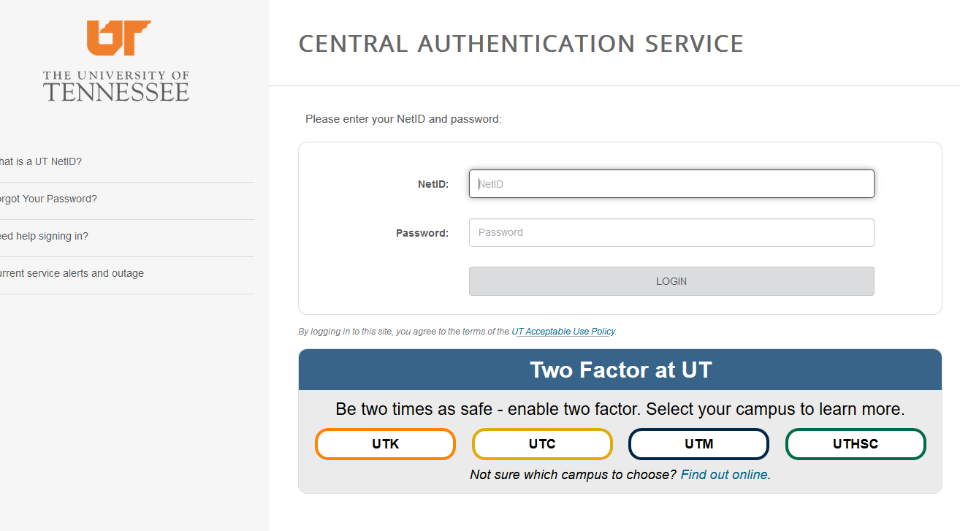

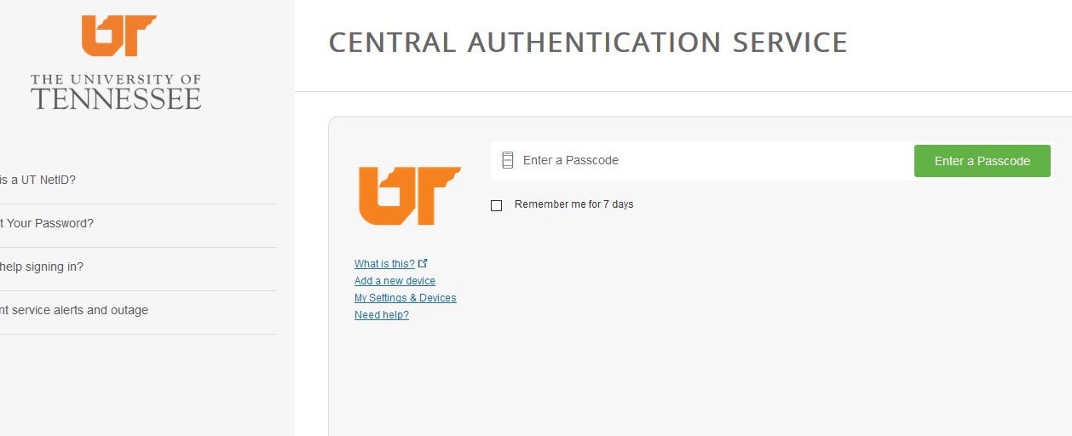
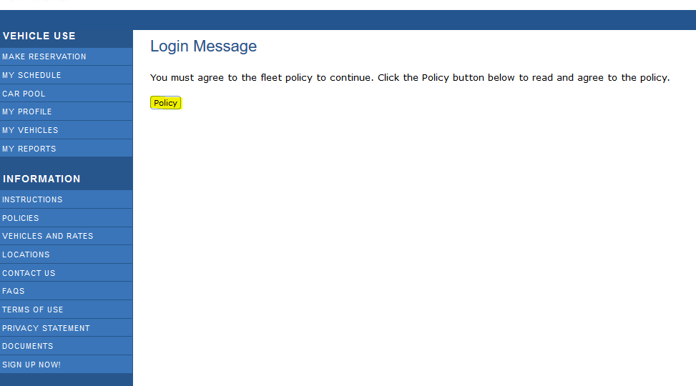

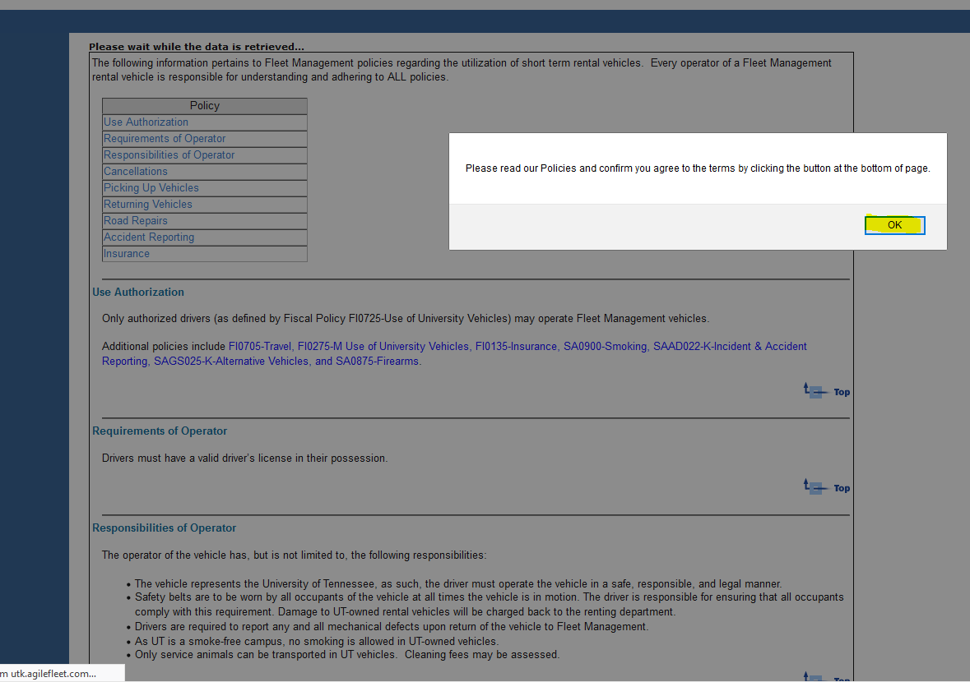
Read and accept at bottom of page.
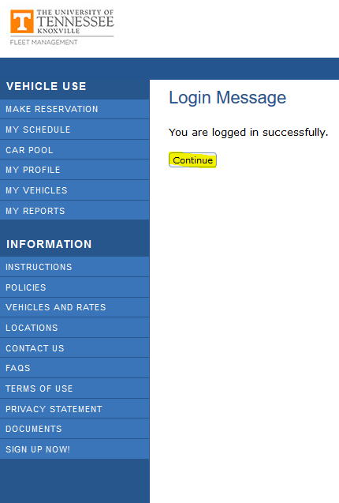

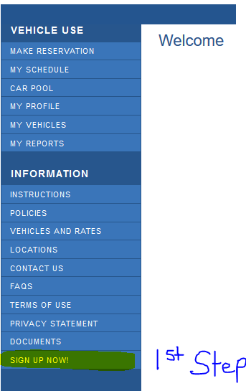

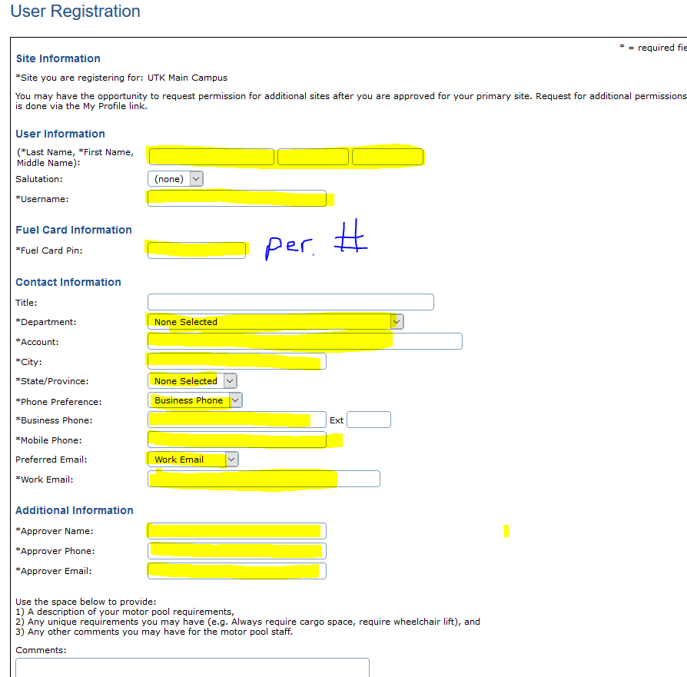

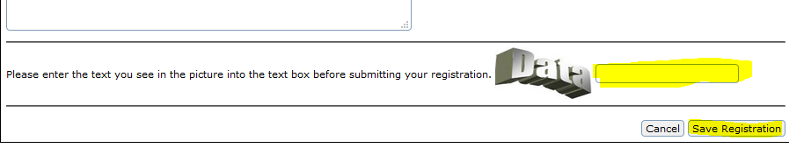
When filling out the “user registration”, everything with an asterisk * has to be filled in. The account number and department has to be the one you, as a “user”, are tied to in IRIS, account number descriptor. Once you are confirmed as a “user” and start to reserve a vehicle, you may change the account number to charge the vehicle rental to. After you register as a user, you have to wait until an admin approves it before you can make a reservation. If you register after hours or weekends, you will not be able to reserve a vehicle. Everyone has to register as a user themselves since you will have to use your UT credentials. Without being a register user, you will not be permitted to get a vehicle or return one.

After this, go to Instructions.
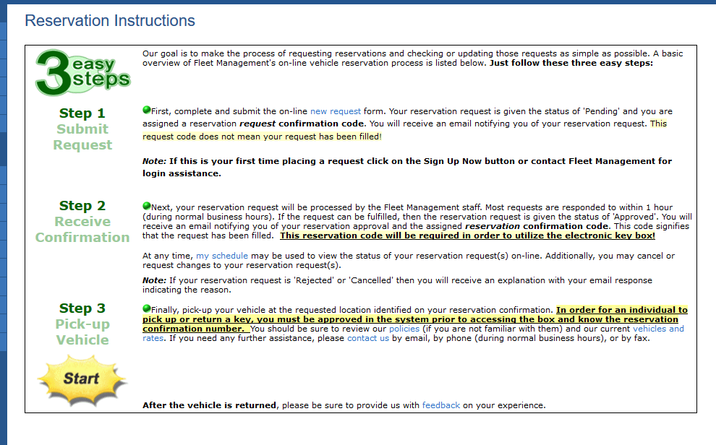

After clicking on Start, it will take you to this page.
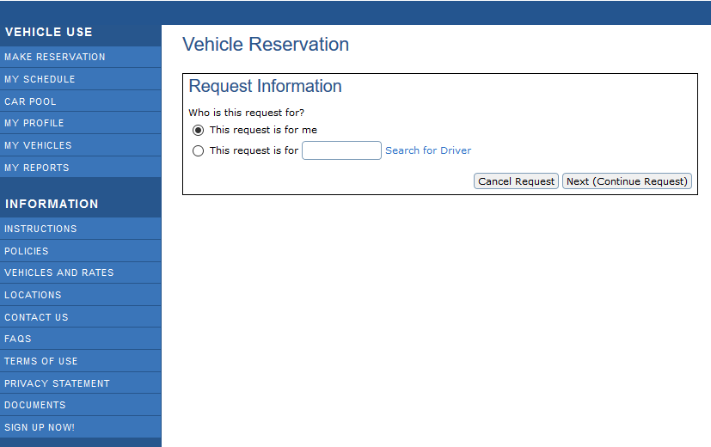
If the reservation is for you, click the top, if you are making it for someone other than yourself, click on second space. Once you have done this, click on NEXT.
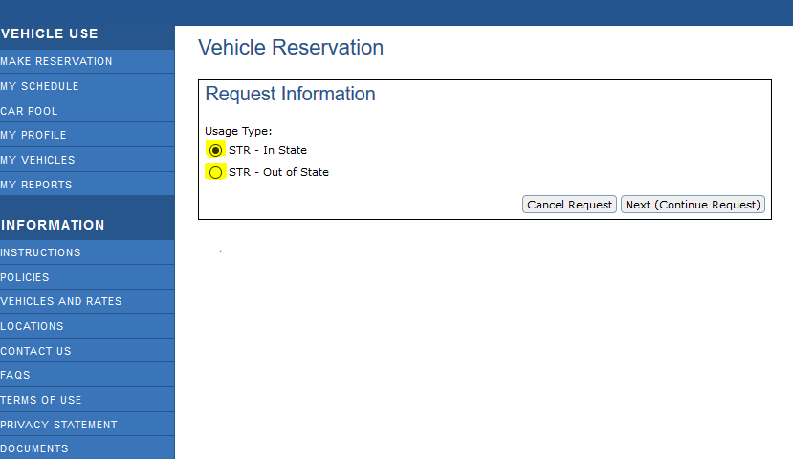
Choose whether the travel is IN STATE or OUT OF STATE.
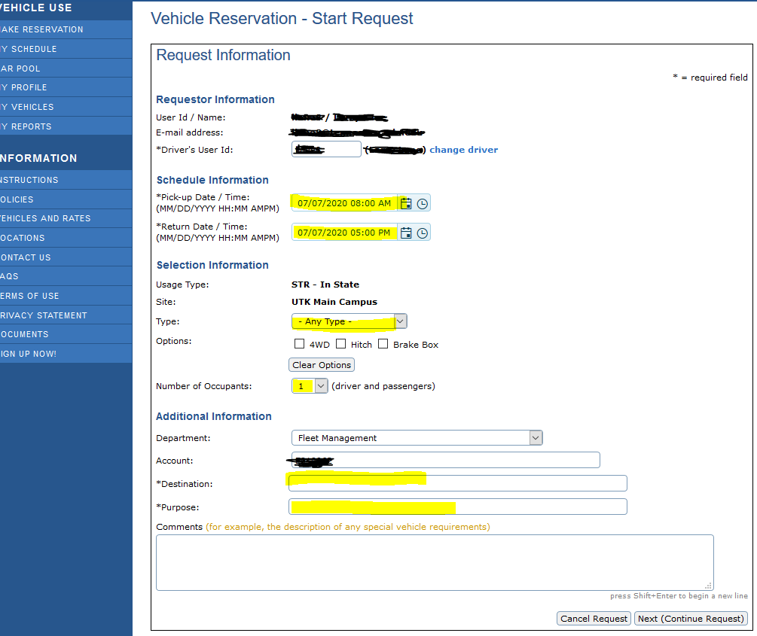
The User ID/Name, Email address, Driver’s User ID, and account number have been marked out. The renter’s information will be there instead.
If you need to charge the rental to a different account number for this rental, you may do so. Put the destination and the purpose of your trip. If you have any special requirements or requests, please put them in the comments section. Click Next to continue.
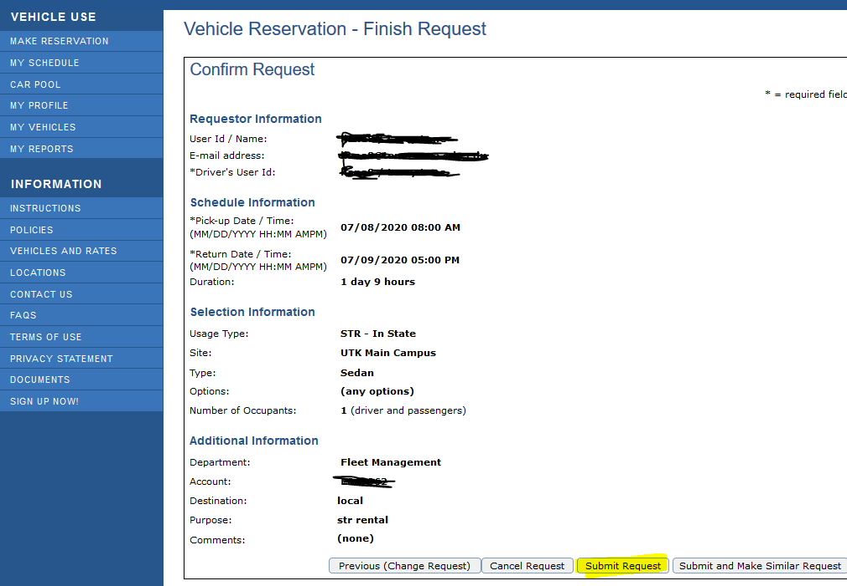
If everything is correct, click on Submit Request. If you need to change something, click on Previous or if you need to cancel, just click Cancel Request. If you need to have multiply reservations, click on Submit and Make Similar.
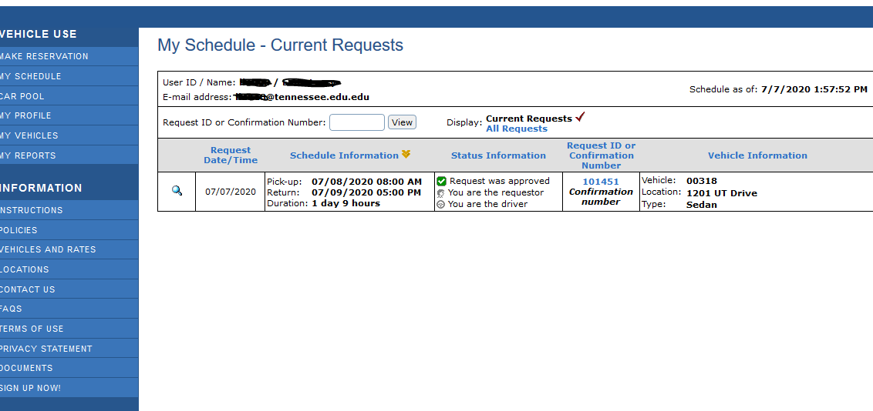
You should see this screen if you chose to Submit Request. If your reservation has been APPROVED you should see a 6 digit number confirmation (as above) in the “Request ID or Confirmation Number”. This means we have a vehicle assigned to you. If in the “Request ID or Confirmation Number” section you see an R followed by 6 numbers, this means you DO NOT have a confirmed reservation. It is only a Request for a reservation. This means, we do not have the type of vehicle you requested and your vehicle may have to be substituted for another “type” of vehicle. If during business hours an admin can assist with this.
Every requester, renter and approver, should receive two emails. The first one is a Request Confirmation (i.e. R plus 6 numbers) which means your request for a vehicle was put into the AGILE system. If a vehicle is available, all will receive a second email. This one is a Reservation Confirmation, (i.e. 6 numbers) which means you have a vehicle assigned to you.

The new key box is located at the back of the building.

